**Aqua Gr****wth**

**SOLUTIONS**

**Milestone 3: Software Market Research Report & Presentation**

**Team Members**

Noah Jacinto

Alexander Vega

Megan Kang

Daniel Vasquez

Jeet Patel

Jaxon Brown

# **Introduction**

In the journey towards creating an innovative and user-friendly plant care solution, our project has undergone a process of user-centered design, where we engaged with a diverse group of users to understand their needs, challenges, and expectations related to plant care. Our refined project idea that emerged from these interactions is a device that passively collects plant information using sensors and sends that data back to a mobile app for automatic notifications and for the user to see. Our vision is to develop a comprehensive and intuitive plant care system that caters to the unique requirements of our users, simplifying the process of plant care while promoting sustainability and environmental consciousness.

Market research is a pivotal phase in the development of our plant care solution. It plays a crucial role in understanding the existing software market landscape, identifying potential competitors, and evaluating their strengths and weaknesses. By conducting a thorough market analysis, we aim to uncover valuable insights that will allow us to learn from existing solutions, pinpoint gaps in the market, and leverage these insights to develop a product that not only meets but exceeds user expectations. By thoroughly assessing the strengths and weaknesses of existing competitors, we can strategically position our plant care system to stand out in the market, offering unique features and addressing pain points identified during the user-centered design activity. This research is fundamental in guiding our product development process, ensuring that our solution is not only user-centered but also commercially viable and capable of making a significant impact in the plant care industry.

# **Market Overview**

*Future Growth Projections for the Soil Sensor Market:*

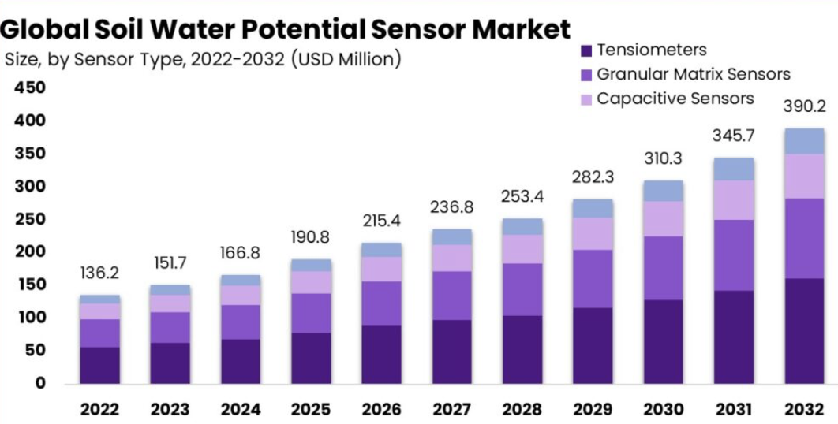

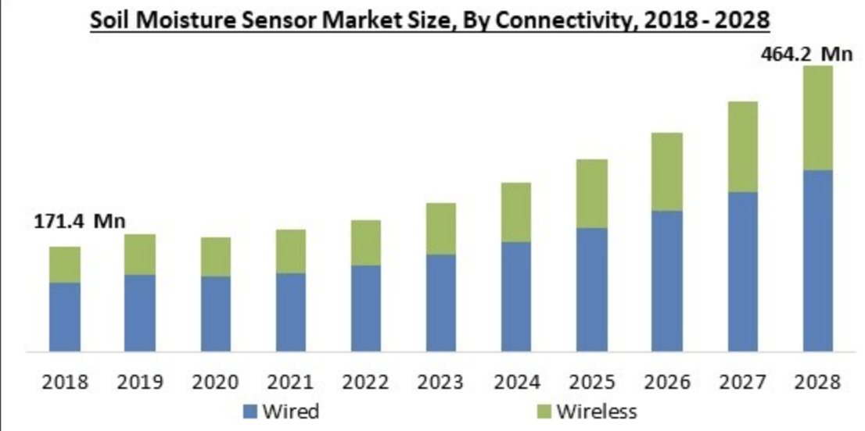

*Market Share and Major Players Trends:*

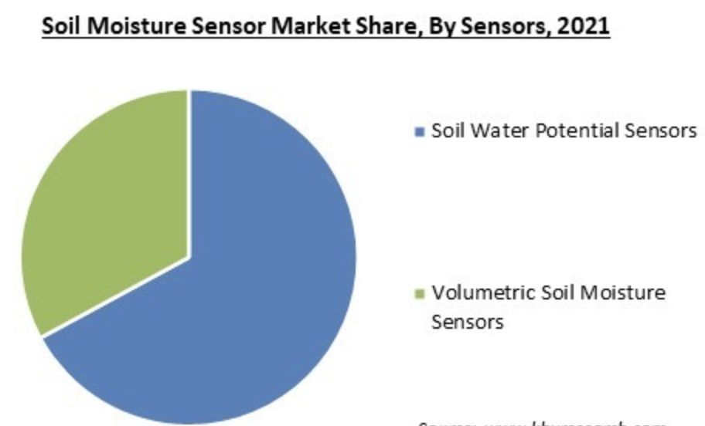

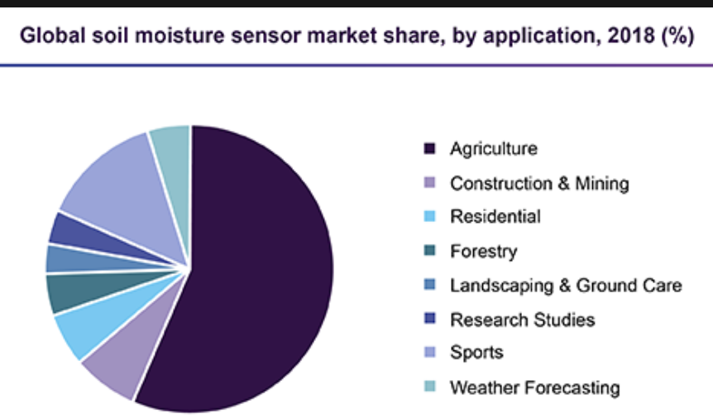

**General Observations:**

***Rising Interest in Plant Care Solutions:*** There is a growing interest in plant care solutions, driven by factors such as urbanization, increased awareness of environmental conservation, and the desire to create green spaces indoors. Many people are looking for user-friendly and innovative ways to care for their plants.

***Integration of Technology:*** Plant sensors are becoming increasingly sophisticated, with the integration of technology such as sensors for monitoring soil moisture, light levels, and temperature. These sensors are typically designed to be user-friendly and provide data to mobile apps for easy access.

***Promotion of Sustainability:*** Sustainability and environmental consciousness are significant drivers in the plant sensor market. Users are increasingly concerned about resource efficiency and the environmental impact of their plant care practices. Plant sensor solutions are designed to help users conserve resources and reduce waste.

***Market Growth:*** As more people recognize the benefits of using plant sensors, the market is experiencing growth. With the market's focus on user-friendly solutions and sustainability, it is likely to continue to expand in the coming years.

# 

# **Competitor Analysis**

**Netro**

**Overview:** Periodically collects the soil moisture, ambient temperature and sunlight condition, the key factors that affect plant growth. It is completely wireless and is designed for outdoors using solid power.

**Features & Offerings:** Wifi connected, solar powered, recommends watering schedules, runs on ios and android devices, LED with customization, waterproof, sunlight, temperature and moisture sensor.

**Hands-on evaluation:**

* **First impressions:**
  + Reviewers emphasize the “modern” aspect of the device such as weather integration and prediction.
  + Whisperer uses a set of sensors to measure weather conditions and plant information and heavily emphasizes mobile applications. Initial setup and configuration is all done throughout the mobile application.
* **Usability and user experience insights:**
  + The whisperer mobile application, lets you set up “zones” for multiple sensors and lets you take sunlight, temperature, and moisture readings at various rates
  + The main menu lets you see your statistics in “live”, “hourly”, “weekly”, and “monthly” panels for your selected zone.
  + Recommended to charge for at least 2 days or reach 60% battery before configuring.
* **Standout features and notable gaps:**
  + Device is modular and lets you add more sensors and increase the number of zones over time.
  + Supports moisture, temperature, and sunlight sensors only.
  + Notable Gaps: Device only uses 2.4GHz and may not work with 5Ghz networks and due to solar there may be issues with battery for the device.

**User reviews & ratings:**

* Critical reviews: Inaccurate, unreliable, doesn't work in low-light conditions (for outdoor use only), low durability (many reviews state the device stopped working), only way to charge is solar (no alternatives).

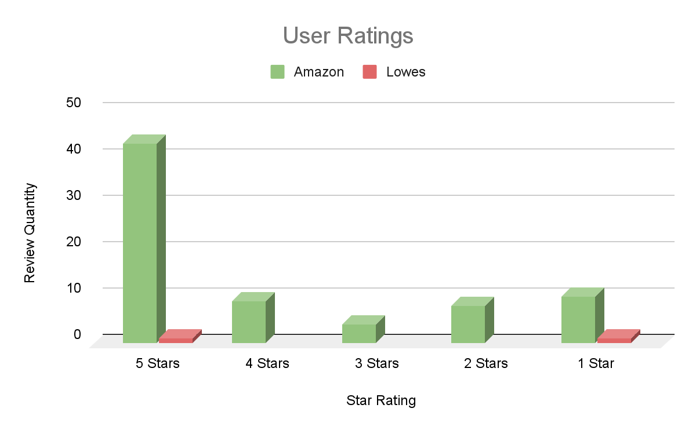

**Rachio**

**Overview:** A device that measures and reports the weather, aiding in watering scheduling. View real time data in the Rachio app such as haptic winds, sonic wind, ambient light, temperature and humidity sensing information. It used to adjust schedules throughout the season and shift watering daily. Tempest reports temperature, solar radiation and UV, humidity, barometric pressure, wind speed and direction, dew point, lightning strikes, rainfall and more.

**Features & Offerings:** Completely wireless, solar-powered, easy to install, low maintenance, alexa-enabled

**Hands-on evaluation:**

* First impressions:
  + Sleek design and easy setup make a positive initial impact. Wireless, solar-powered operation adds convenience, and the variety of sensors promises comprehensive data collection.
* Usability and user experience insights:
  + Intuitive app interface for real-time data.
  + Hassle-free wireless, solar-powered operation.
  + Integration with Alexa enhances user control.
  + Complex setup for non-tech-savvy users.
  + Customization process in the app needs simplification.
* Standout features and notable gaps:
  + Comprehensive range of sensors enriches user understanding of garden conditions.
  + Minimal maintenance due to wireless, solar-powered design.

**User reviews & ratings:**

Critical Review: Rain and wind readings are not accurate or reliable

Relatively short lifespan

Some communication issues

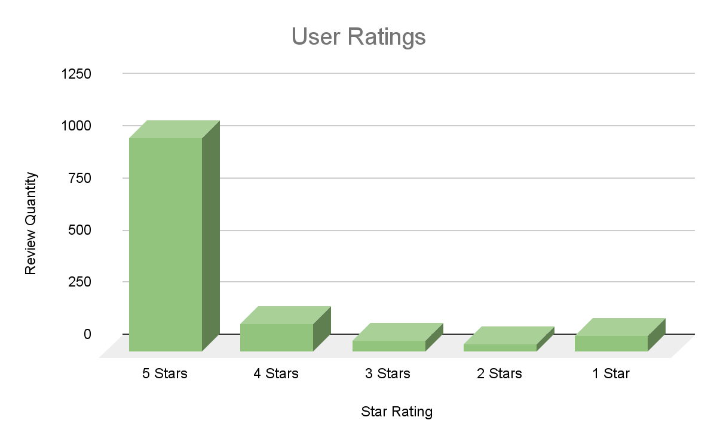

**Sun Joe**

**Overview:** 3-in-1 soil meter that tests for proper moisture, pH and sunlight for healthier soil and happier plants. It is designed for indoor and outdoor use for testing condition and plant care in lawns, gardens, homes and greenhouses. Water before testing and select desired soil testing mode, then remove the probe.

**Features & Offerings:** light sensor measure light intensity, moisture sensor, pH sensor, no batteries required, lightweight, gauge for easy monitoring

**Hands-on evaluation:**

* **First impressions:**
  + The quality material of the device itself seems relatively cheap but what can you expect, the cost is also low so it makes sense.
* **Usability and user experience insights:**
  + The device is ready to use out of the box which is really nice (no need for batteries).
  + Something I am unsure of is whether or not the ph sensor works or not.
  + Everytime I want to measure a different aspect of the plant I have to toggle a switch, it is not the end of the world but it is a hassle.
* **Standout features and notable gaps:**
  + The device is very easy to use straight out of the box, you literally just chuck it into the ground or pot and water your plant then see how the meter adjusts.

**User reviews & ratings:**

**Critical Reviews:** Issue regarding one of the sensors on the device not working/providing inaccurate data (ph sensor). A lot of users tend to use the device for a specific functionality, not all of them, for example only moisture or only ph.

* One user mentioned how it would be helpful it the device could be calibrated (for moisture use only)
* Another mentioned how it was great that no calibration was needed

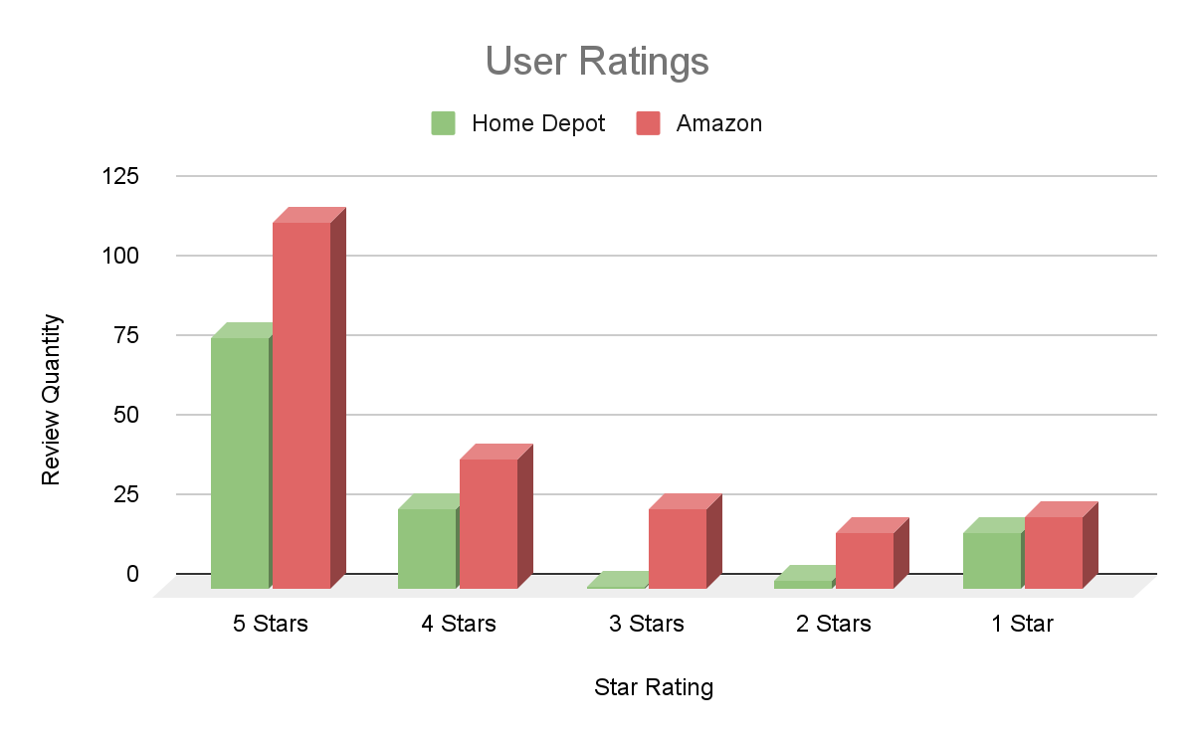

**Diivoo**

**Overview:** A soil moisture meter that connects to your phone via Bluetooth, displaying real-time temperature and humidity data. It provides information on your plants' properties and watering frequency, as well as soil temperature and humidity-zoe reference table. Lists preset data on the watering frequency, attributes and standard temperature and humidity ranges for 32 most common plants.

**Features & Offerings:** Bluetooth connectivity, 32 predefined plants, custom list for 30 additional plants, plug and play, and custom plant recommendations.

**Hands-on evaluation:**

* **First impressions:**
  + Their device seems well made with a high build quality leaving a positive impression among users. Contains a screwdriver for the setup and built out of rubber, metal and plastic pieces.
* **Usability and user experience insights:**
  + Users claim the setup is easy and convenient when connecting to a smartphone app. The device is meant to be “plug and play” with little to no setup required.
  + The app's interface is intuitive and provides weather readings only for temperature, humidity, and moisture.
  + Users are able to access a multitude of plants but are restricted to only 30 plants. The plants however range from different kinds of plants.
* **Standout features and notable gaps:**
  + Many people value their database for various plant types and ideal conditions for plants.
  + The device was criticized for its limitation in storing profiles for only up to 30 types of plants, which some users found restrictive.
  + A few users expressed concerns about the accuracy of moisture readings, suggesting that the device may sometimes provide inaccurate data.

**User reviews & ratings**:

**Critical Reviews:** Usability issue regarding users having to press a button on the device to get readings (repetitive, annoyance for users). Has Limited memory for user defined plants. Batteries not included.

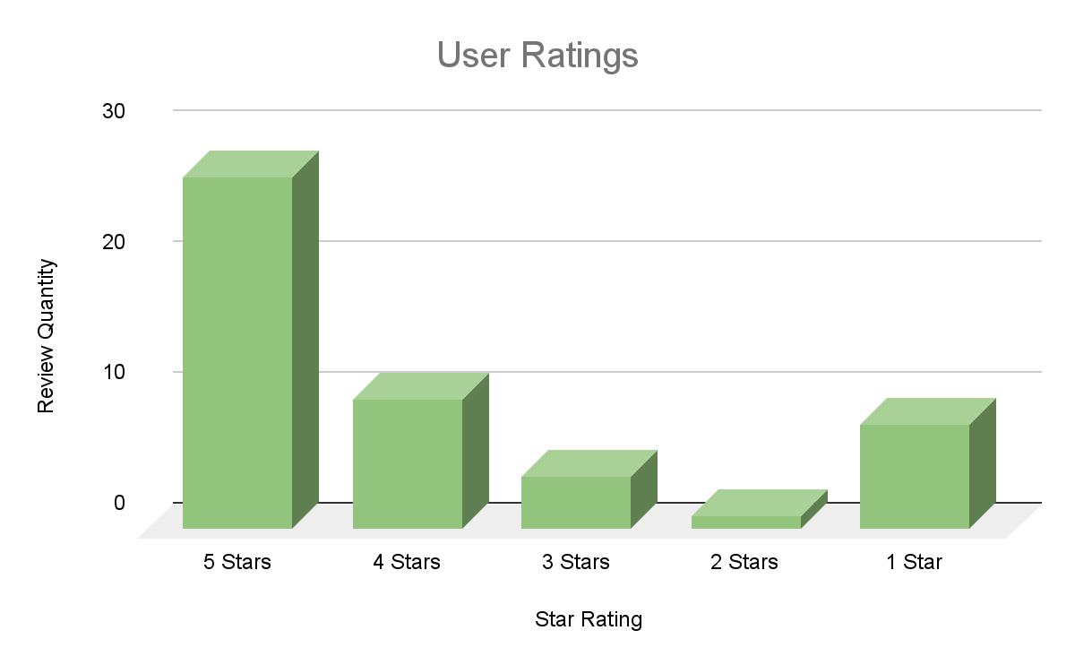

# 

# **Opportunity Assessment:**

**SWOT Analysis:**

| **Strengths**:  **Automatic Notifications**: The system's ability to send automatic notifications to users regarding their plants' needs.  **Comprehensive Data Analysis**: The accompanying mobile app processes collected data and provides users with detailed insights into their plants' growth, water, and light requirements.  **User-Friendly Interface**: The intuitive and easy-to-navigate mobile app makes it accessible for users of all technical backgrounds.  **Reusability**: Allows users to add multiple plant profiles for their garden. The addition of plant profiles lets you reuse the device on multiple plants. | **Weaknesses**:  **Dependence on Sensors**: The functionality heavily relies on the accuracy and reliability of sensors. Malfunctions or inaccuracies in sensor readings could compromise the system's effectiveness.  **Dependency on Technology**: Reliance on mobile apps and sensors might pose challenges for users uncomfortable with technology or those in regions with limited network coverage.  **Bluetooth Limitation:** Data transmission must be done within proximity of the hardware components. |
| --- | --- |
| **Opportunities**:  **Machine Learning**: Implement advanced machine learning algorithms to analyze data patterns, enabling predictive plant care suggestions.  **Solar Powered Hardware:** Solar panels on the sensor to ensure the device does not run out of battery, ensuring reliability.  **Educational Content**: Providing informative content through the app, such as gardening tips, tutorials, and articles, can engage users and enhance their gardening skills.  **Integration with Smart Home Systems**: Integrating the plant care system with existing smart home platforms like Amazon Alexa or Google Assistant. | **Threats**:  **Competition**: Established competitors like Netro, Rachio, Sun Joe, and Diivoo pose a threat since they all have similar features.  **Brand Recognition**: Established competitors might have stronger brand recognition and customer trust, making it challenging for AquaGrowth Solutions to convince users to switch from familiar brands to a new, innovative solution.  **Market Saturation**: If the market becomes saturated with similar smart gardening products, consumer choices might become overwhelming, making it harder for AquaGrowth Solutions to stand out. |

**Gap Analysis:**

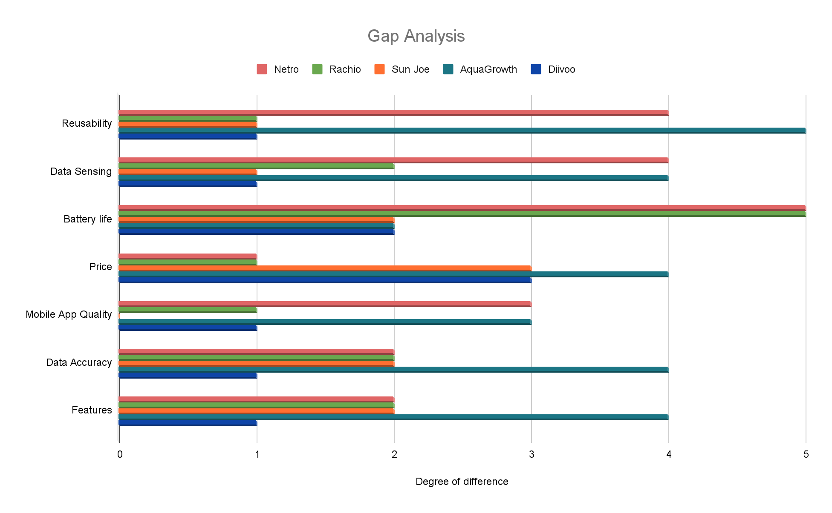

In this table we have values from 1 to 5 which represents the degree of difference between AquaGrowth and its competitors through various metrics. 1 represents a minor gap and 5 represents a major gap compared to the others. For the vertical row, we chose a few different aspects that can be found in all competitors such as “Reusability”, “Data Sensing”, “Battery life”, “Price”, “Mobile App Quality”, “Data Accuracy” and “Features”.

Analyzing this graph we can see that our product is on par with our competitors in terms of data sensing, app quality, and battery life. To stand out from other competitors, we will prioritize areas in reusability, data sensing, data accuracy, and features. While some competitors

offer limited plant profiles for their device, we plan to provide an unlimited number of plant profiles for when users expand their garden. Aside from reusability, Data Accuracy is an important factor because reliable and precise data can minimize improper plant care. Lastly for data sensing our product will focus on automatic collection of data regarding plant moisture, sunlight, temperature, and humidity. In doing so we can bridge the gap between our competitors and make our product more appealing in the market.

# **Strategic Positioning**

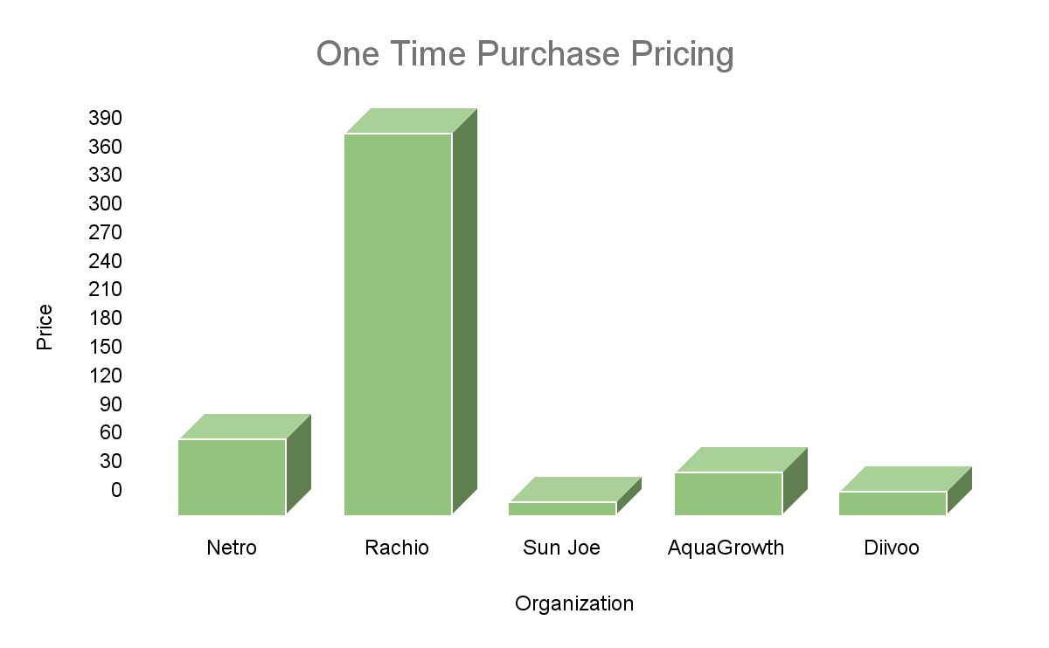

**Usability**

|  | [Netro](https://netrohome.com/en/shop/products/whisperer) | [Rachio](https://rachio.com/products/weatherflow-tempest/) | [Sun Joe](https://www.homedepot.com/p/Sun-Joe-3-In-1-Soil-Meter-with-Moisture-PH-and-Light-Meter-for-Indoor-Outdoor-Gardens-SJ-MMPH1/319834887) | **AquaGrowth** | [Diivoo](https://www.amazon.com/Diivoo-Moisture-Bluetooth-houseplant-bedrooms/dp/B0BQYJTB8W/ref=sr_1_15?crid=SFSH45PLZCOZ&keywords=moisture+sensor+app&qid=1698685540&sprefix=moisture+sensor+app%2Caps%2C170&sr=8-15) |
| --- | --- | --- | --- | --- | --- |
| Reusability | Unlimited | Limited | Limited | **Unlimited** | Limited |
| Data Sensing | Automatic | Automatic | Manual | **Automatic** | Manual |
| Battery life | Solar | Solar | Battery | **Battery** | Battery |
| Price | Expensive | Expensive | Competitive | **Competitive** | Competitive |
| Mobile App Quality | Good | Basic | None | **Good** | Basic |
| Data Accuracy | Moderate | High | Moderate | **High** | Moderate |
| Sensor Features | Rich | Moderate | Moderate | **Rich** | Moderate |

**Feature Set**

|  | [Netro](https://netrohome.com/en/shop/products/whisperer) | Rachio | [Sun Joe](https://www.homedepot.com/p/Sun-Joe-3-In-1-Soil-Meter-with-Moisture-PH-and-Light-Meter-for-Indoor-Outdoor-Gardens-SJ-MMPH1/319834887) | **AquaGrowth** | [Diivoo](https://www.amazon.com/Diivoo-Moisture-Bluetooth-houseplant-bedrooms/dp/B0BQYJTB8W/ref=sr_1_15?crid=SFSH45PLZCOZ&keywords=moisture+sensor+app&qid=1698685540&sprefix=moisture+sensor+app%2Caps%2C170&sr=8-15) |
| --- | --- | --- | --- | --- | --- |
| Humidity Sensor | X | ✔ | X | **✔** | ✔ |
| Temperature Sensor | ✔ | ✔ | X | **✔** | ✔ |
| Moisture Sensor | ✔ | X | ✔ | **✔** | ✔ |
| Sunlight Sensor | ✔ | X | ✔ | **✔** | X |
| Mobile Application | ✔ | ✔ | X | **✔** | ✔ |
| Dashboard | ✔ | ✔ | X | **✔** | ✔ |
| Plant Guide | X | X | X | **✔** | X |
| Weather Integration | ✔ | ✔ | X | **✔** | X |
| Bluetooth | ✔ | X | X | **✔** | ✔ |
| Wifi | ✔ | ✔ | X | **X** | X |

**Discuss how your project differentiates from others:**

AquaGrowth is a plant sensor device with a few notable competitors such as Netro, Rachio, Sun Joe, and Diivoo that offer their own takes on plant monitoring and plant care solutions. The devices can be categorized into smart devices and a standalone device.

In the area of smart devices, AquaGrowth competes against Netro, Rachio, and Diivoo directly. These devices primarily share a common objective of collecting and presenting plant related data towards gardeners. The main difference between smart devices and standalone devices, are the digital and data integration in mobile applications. For smart devices, competitors tend to have a mobile application, dashboard, and wireless connection connected to their plants through bluetooth or WiFi. These features provide information to gardeners and allow them to care through different aspects for their plants. On the other hand, there are standalone devices such as Sun Joe. These devices lack the digital aspect such as mobile application, bluetooth and WiFi, but rather prioritize sensor technology and physical displays compared to the smart devices. These standalone devices tend to follow a more traditional and budget friendly approach.

Comparing AquaGrowth to the competitors devices, there are a few noticeable gaps compared to competitors, particularly in the area of device features. Our core objective revolves around incorporating multiple sensors including Humidity, Temperature, Moisture and Sunlight sensors. Some of our competitors may offer one or two of these sensors but do not provide support for all sensors altogether. The common sensor among these competitors are moisture and temperature sensors, which seem to be our default sensors. Therefore, AquaGrowths distinctive feature is providing gardeners with a complete set of sensors in a device.

Aside from features, we plan to focus on plant device reusability and extended battery life. While some competitors like Netro and Diivoo offer reusability features, they come with limitations particularly concerning the number of plant profiles within their mobile application. To address this issue, our plan is to introduce an unlimited number of plant profiles in the mobile application. Additionally, we want to make the selection of plant profiles easy and intuitive to provide for a wide variety of plants. On the other hand competitors use solar powered options, while we will take the Battery approach for the device. This decision is driven through a financial aspect, because we noticed that solar power makes the device extremely expensive and we plan to make the device convenient and budget friendly for consumers.

**Potential challenges and strategies to address.**

Our team anticipates a few potential challenges, concerning Bluetooth support and Data Accuracy. Ensuring a Bluetooth Connectivity between a physical device and the mobile application poses challenges related to data transmission, compatibility and distance limitations. By addressing these issues it will ensure a seamless and reliable connection for users. Our strategy is to apply “GATT” which is a Generic Attribute Profile to our devices. This is a bluetooth approach that uses Attribute Protocol to allow devices to transfer data back and forth using clients and peripherals.

On the other hand, we may face data inaccuracy issues and may affect plant monitoring. If we have inaccurate data, it can lead to improper plant care and lead users to provide bad reviews. Therefore to tackle this concern, we plan to prioritize sensor calibration and research accurate ways to deliver reliable information to users. In addition to accurate information, we would need to provide unlimited plant profiles for custom plants to boost reusability. To create a generic interface for unlimited plant profiles may be challenging in the development process and lead to scalability issues. Aside from development difficulties, optimizing this data inside of a database would be another challenging factor. Therefore to address these issues we would need to research generic design patterns for unlimited plant profiles along with optimized database techniques to address these challenges.

# **Conclusion**

Our market research has highlighted a rising interest in plant care solutions with a growing focus on sustainability and ease of use. After analyzing existing solutions from competitors, customers place a huge importance on sensor accuracy, affordability, and a device that is simple to use. To address the concerns and differentiate ourselves in the market, AquaGrowth Solutions will offer a unique set of features including a complete set of sensors, unlimited plant profiles, educational content, and reusability.

Moving forward, our focus will be on sensor accuracy and calibration to provide our users with reliable data. We also plan to enhance our product's appeal by providing our users with educational content and exploring the integration of machine learning algorithms to recommend plant care suggestions. AquaGrowth Solutions intends to meet the needs of all gardeners by developing an easy to use solution. Our product will provide comprehensive data analysis, plant care information and recommendations alongside an easy to use companion app. Whether our user is a veteran or just getting into gardening, our product will streamline the gardening experience.